“AI Powered Hospital Information Management System”

Project Code:
HIMS-AI-2526
Project Team:
Ali Akbar BSCS51F22R036
Muhammad Najee Ullah Noon BSCS51F22S043
Project Supervisor:
Mr. Aamir Zia
Project Manager:
Dr. Muhammad Ilyas
Submission Date:
09-05-2026

Contents
Chapter 01: Introduction 4
1.1 Purpose of the document 4
1.2 Project Overview 4
1.3 Project Scope 5
1.4 Project Timeline 6
Chapter 02: Overall System Description 7
2.1 User Characteristics 7
2.1.1 Primary Users – Doctors 7
2.1.2 Secondary Users – Administrative Staff 7
2.1.3 Operational Users – Receptionists 7
2.1.4 Tertiary Users – Patients 8
2.2 Operating environment 8
2.3 System constraints 9
Chapter 03: Functional Requirements 10
Chapter 04: Non-Functional Requirements 14
4.1 Performance Requirements 14
4.2 Safety Requirements 14
4.3 Security Requirements 14
4.4 User Documentation 15
Chapter 05: Assumptions and Dependencies 16
5.1 Assumptions 16
5.2 Dependencies 16
Chapter 06: Use Cases 17
Use Case 1: AI-Assisted Medical Documentation 17
Use Case 2: Appointment and Queue Management 18
Use Case 3: Patient Record Access 19
Use Case 4: Prescription Management 20
Use Case 5: Secure Communication and Notifications 20
Chapter 07: Implementation Overview 22
7.1 Technology Stack 22
7.2 System Architecture Overview 23
7.3 Module Implementations 25
7.3.1 AI Consultation Recording & Documentation Module 25
7.3.2 Appointment & Queue Management Module 27
7.3.3 Patient Record & Prescription Management Module 27
7.3.4 Communication & Notification Module 28
7.3.5 Administrative Dashboard Module 29
7.3.6 Authentication & Access Control Module 30
7.4 Deployment Strategy 32
7.4.1 Frontend Application 32
7.4.2 Backend Service 33
7.4.3 Database Deployment 33
7.4.4 AI & Voice Processing Services 33
7.4.5 File & Report Management 33
7.5 Code/API Documentation 33
Chapter 08: Design Document 33
8.1 State Transition Diagram 34
8.2.1 DFD Level 0 35
8.2.2 DFD Level 1 36
8.2.3 DFD Level 2 37
8.3 Class Diagram 38
8.4 Sequence Diagram 38
8.5 ER Diagram 40
Chapter 09: UI Interfaces 41
9.1 Landing Page 41
9.2 Register and Login Page 42
9.3 Dashboard 43
9.3.1 Patient Dashboard 43
9.3.2 Doctor Dashboard 45
9.3.3 Receptionist Dashboard 47
9.3.4 Admin Dashboard 49
Chapter 10: Functionality & Performance Testing 51
Chapter 11: References 51

Chapter 01: Introduction

1.1 Purpose of the document
This document has been prepared to provide a comprehensive overview of the design, development, and implementation of the AI Powered Hospital Information Management System (HIMS), a smart healthcare solution aimed at improving hospital operations and enhancing patient care through intelligent automation. The purpose of this document is not only to explain the technical structure of the system but also to describe the planning, methodologies, and problem-solving approaches used during its development.
It serves as a reference for all stakeholders involved in the project, including the development team, hospital administrators, healthcare professionals, and academic evaluators. By clearly presenting the project objectives, system architecture, features, workflows, user roles, implementation strategies, and testing approaches, the document ensures that the system is understood from both technical and operational perspectives.
Additionally, the document helps maintain transparency throughout the development lifecycle, supports effective decision-making, and provides a foundation for future maintenance, scalability, and feature enhancements. Whether the system is being reviewed for academic evaluation, practical deployment, or future expansion within healthcare institutions, this document provides all essential information regarding the proposed solution and its functionalities.

1.2 Project Overview
Modern hospitals often struggle with inefficiencies caused by manual data entry, fragmented record-keeping, and time-consuming administrative processes. These challenges lead to delays in patient care, errors in documentation, and an increased workload on medical staff.
To address these issues, the AI-Powered Hospital Information Management System (HIMS) is proposed as an intelligent, automated platform that integrates speech recognition and natural language processing to streamline hospital workflows.
The system functions as follows:
- AI-Based Conversation Recording and Analysis: The system listens to doctor–patient interactions in real time, identifies the speaker, and extracts key medical information such as symptoms, diagnosis, prescribed treatments, and follow-up details.
- Doctor Confirmation and Data Storage: Before saving, the extracted data is displayed to the doctor for verification. Once confirmed, it is automatically stored in a centralized hospital database.
- Dedicated Dashboards:
- Doctor Dashboard: Enables doctors to view patient histories, review notes, and manage consultations.
- Admin Dashboard: Allows hospital administrators to manage records, monitor data flow, and ensure system compliance.
- Patient Portal: Provides patients with access to their medical history, prescriptions, and reports.
The core objective of this project is to reduce administrative workload, improve record accuracy, and enable real-time access to patient information. By leveraging advanced technologies such as Whisper for speech-to-text processing, GPT-based models for data extraction, and PostgreSQL for secure data management, the proposed system enhances hospital efficiency and promotes the adoption of AI-driven healthcare solutions.

1.3 Project Scope
The scope of the AI-powered Hospital Information Management System (HIMS) is defined by its focus on improving patient record management, reducing administrative workload, and supporting accurate medical documentation through AI assistance, while keeping doctors in control of validation. The project is specifically designed for healthcare institutions and has clear boundaries on what it will and will not cover.
Inclusions (What the System Will Do):
- AI-Assisted Medical Note Creation: “The system captures doctor-patient conversations, highlights relevant medical details (symptoms, diagnoses, tests), and presents them for doctor confirmation before saving to the database [4].”
- Smart Appointment and Queue Management: Patients can book appointments on a first-come-first-serve basis and monitor their queue position in real-time to minimize hospital waiting time and overcrowding.
- Controlled Patient Self-Registration: Patients can create their own accounts through the registration system; however, the accounts will remain inactive until verified and approved by authorized hospital staff to ensure security and authenticity of patient information.
- Centralized Patient Record Management: Hospitals can maintain structured medical histories, accessible to authorized staff across visits.
- Prescription Management System: The platform stores doctor-specific prescription history, allowing healthcare providers to review previous medications and treatment records for continuity of care.
- Integrated Staff Dashboard: Enables staff to verify or edit AI-suggested notes, manage patient data, and oversee hospital operations such as scheduling and reporting.
- Integrated Communication Module: The system provides a secure messaging platform for healthcare-related communication, follow-ups, notifications, and information exchange within the hospital management environment.
- Secure Patient Access: Patients can receive their reports digitally through their profile or via staff-provided printed documents.
- Transparent Billing and Report Access: Patients can access billing information, payment details, and downloadable medical reports digitally through their accounts.
- Healthcare Data Analysis: Aggregated hospital data can be used to analyze patient trends, workload distribution, consultation frequency, and operational efficiency.
Exclusions (What the System Will Not Do):
- Autonomous Medical Decision-Making: The system will not independently diagnose diseases, prescribe medicines, or recommend treatments without doctor involvement and approval.
- Cross-Hospital Data Sharing: Patient data will not automatically transfer between hospitals unless formally integrated with external systems.
- Non-Medical Hospital Operations: The system will not handle unrelated tasks such as payroll, pharmacy stock management, or facility maintenance.
- Emergency Response Management: The platform is not intended to function as an emergency dispatch or ambulance coordination system.
- Advanced AI Disease Prediction: The current version of the system will not include predictive analytics for disease forecasting or automated medical risk assessment.
- Multilingual Limitation: The system currently supports English, Urdu, and Punjabi only and does not provide support for additional regional or international languages in the present implementation.

1.4 Project Timeline

Figure 1: Project Timeline - Gantt chart

Chapter 02: Overall System Description
The AI-Powered Hospital Information Management System (HIMS) is designed for multiple classes of users within a healthcare setting, each with specific roles, technical familiarity, and system access levels.

2.1 User Characteristics

2.1.1 Primary Users – Doctors
Doctors are the main users of the system, responsible for patient diagnosis, treatment, and record validation. They interact with the system during consultations, where the AI automatically records and transcribes doctor-patient conversations, extracts relevant medical information (such as symptoms, diagnoses, and prescribed medications), and presents it for confirmation. Doctors then review, edit if necessary, and approve the extracted information before it is stored in the database.
This user group requires an interface that is quick, accurate, and minimally intrusive to their workflow. Since doctors are typically focused on patient care rather than data entry, the system focuses on automation, clarity, and reliability in displaying AI-generated medical summaries.

Secondary Users – Administrative Staff
Administrative staff, including hospital managers and data officers, form the second key user group. Their role involves managing hospital data and maintaining compliance with privacy regulations, and monitoring daily operations. They interact with the admin dashboard to view patient activity logs, manage user accounts, oversee system performance, and generate analytical reports for hospital management.
These users are moderately technical and require secure login credentials. The dashboard is designed with a focus on usability and efficient data management, allowing them to perform tasks without deep technical expertise.

2.1.3 Operational Users – Receptionists
Receptionists are operational users responsible for managing front-desk activities and assisting doctors in daily patient handling. Each receptionist is assigned to a specific doctor and can only manage operations related to that doctor. Their responsibilities include patient registration, appointment scheduling, queue management, verification of patient details, and assisting patients during hospital visits.
Receptionists interact with a restricted dashboard that provides access only to the assigned doctor’s appointments, patient queues, and related operational data. This role-based access control helps maintain patient privacy and ensures organized workflow management within the hospital.
The system interface for receptionists is designed to be simple, responsive, and easy to use, enabling efficient handling of routine administrative tasks with minimal technical complexity.

2.1.4 Tertiary Users – Patients
Patients are indirect users of the system who benefit from AI-generated and doctor-verified medical records. They can access their visit history, prescriptions, and reports through a patient portal or via hospital assistance. Since some patients may lack technological access or literacy, the system ensures that staff can retrieve and provide printed or digital copies of medical information when needed.
This group’s interaction is limited but essential for ensuring transparency, continuous care, and patient empowerment in the healthcare process.

2.2 Operating environment
The AI-Powered Hospital Information Management System (HIMS-AI) will operate within a secure, cloud-enabled healthcare environment designed to ensure efficiency, scalability, and data protection. The following outlines the key components of its operating context:
• Web-Based Accessibility:
The HIMS platform is entirely web-based, allowing access through standard browsers such as Google Chrome, Microsoft Edge, and Mozilla Firefox. Doctors, administrators, and patients can use the system from desktop or mobile devices, enabling flexibility in hospital operations.
- Cloud Hosting and Storage:
The system will be hosted on a secure cloud infrastructure to ensure high availability, automated backups, and scalability. This environment supports continuous uptime for critical hospital operations and facilitates secure remote access when needed.
- Hardware and Software Requirements:
The hospital environment will utilize standard computer systems with at least 8GB RAM and a stable internet connection. The system backend will be developed using Django, while the frontend will employ React.js for responsive interfaces. The AI models for transcription and entity extraction will be integrated through Whisper AI and spaCy.
- Database and API Integration:
The system will use PostgreSQL for storing structured medical data and patient histories. It will also integrate APIs for AI transcription, natural language processing, and authentication services to ensure smooth communication between modules.
- Operating System and Compatibility:
HIMS will be compatible with major operating systems, including Windows, macOS, and Linux, ensuring seamless deployment across diverse hospital IT infrastructures. The platform is also designed to integrate with existing hospital devices and systems while maintaining compliance with data privacy standards such as HIPAA.

2.3 System constraints
Despite being designed for efficiency, automation, and scalability, the AI-Powered Hospital Information Management System (HIMS-AI) operates under several constraints that may influence its overall performance and implementation:
- Software Constraints:
The system’s AI modules, including Whisper AI for transcription and spaCy for medical entity extraction, depend on stable third-party APIs and pre-trained models. Any updates or service interruptions in these tools could affect system accuracy and performance.
- Hardware Constraints:
The transcription and AI processing components require systems with sufficient computing power (minimum 8GB RAM and multi-core processors). Hospitals with outdated systems or limited network infrastructure may experience slower processing times.
- Cultural and Language Constraints:
Since doctor-patient conversations may involve a mix of Urdu, Punjabi and English, the system’s multilingual transcription model may face limitations in perfectly recognizing accents, dialects, or regional variations, possibly affecting the data accuracy.
- Legal and Privacy Constraints:
The system must comply with healthcare data protection laws (e.g., HIPAA or local equivalents). Strict consent is required for recording conversations, and data encryption is mandatory to prevent misuse of sensitive patient information.
- Environmental Constraints:
In busy or noisy hospital environment, background sounds can affect audio clarity and reduce transcription accuracy. Use of high-quality microphones and sound-isolated consultation rooms is recommended to mitigate this issue.
- User Constraints:
Some users, such as elderly patients or non-technical staff, may struggle to interact with the web portal or dashboards. Simplified user interfaces and staff assistance will be necessary for accessibility.
- Third-Party Component Limitations:
Off-the-shelf AI services (e.g., Whisper, Hugging Face models) may have rate limits, language support restrictions, or licensing terms that constrain large-scale deployment without enterprise subscriptions.

Chapter 03: Functional Requirements

Patient Registration and Management | - The system allows hospital staff to register new patients by entering demographic details, contact information, and medical history. Patient can register his account but it will be inactive unless verified by the system.  Patients can be assigned a unique hospital ID for future tracking and appointments.  - The system enables editing, updating, and searching of patient records quickly and securely.
Appointment Scheduling | - Doctors and receptionists can schedule, reschedule, or cancel patient appointments through the system. Receptionist will only assist to a specific doctor.  - Patients can book appointments on a first-come-first-serve basis and monitor their queue position in real-time to minimize hospital waiting time and overcrowding.  - The system ensures no time conflicts in doctor scheduling and maintains daily appointment logs.
Electronic Medical Records (EMR) | - The system stores and manages patient medical records, including diagnoses, prescriptions, and treatment history.  Authorized doctors can update medical records after each visit.  - Records are accessible only to authorized personnel to ensure confidentiality.
Billing and Payment Management | - The system automatically generates bills based on the services provided.  - Supports multiple payment modes such as cash or online billing methods like JazzCash or Easypaisa. Payment can be refunded in case of the appointment is cancelled.  - Generates invoices and maintains transaction history for audit purposes.
Doctor and Staff Management | - Allows hospital administrators to add, update, or remove doctor and staff profiles.  - Stores details such as specialization, availability.
Authentication and Role Management | Provides secure login for different user roles such as admin, doctor, nurse, pharmacist, and receptionist.  Each role has access to specific modules and data based on authorization level.  Password recovery option is available.
Data Analytics and Reporting | - The system generates statistical and analytical reports for hospital management, such as patient inflow, revenue trends, and medicine consumption.  - Graphical dashboards provide insights into operational efficiency and performance.  - Reports can be exported in PDF format.
Notification and Alert System | - Sends appointment reminders and bill payment alerts notifications to patients via dashboard.  - Notifies staff about unprocessed bills.  - Allows admins to configure notification preferences.
Backup and Recovery | - The system automatically backs up critical data on a scheduled basis to prevent loss due to system failure.  - Admins can restore data from backup when necessary.  - Ensures data integrity and business continuity.
Exclusions | • The system does not provide telemedicine or video consultation features.  • External insurance claim processing systems are not integrated in the current version.  • Real-time integration with third-party pharmacy or lab systems is outside the current project scope.
Actors | • Patients: Register, book appointments, and access their records.  • Doctors: Manage appointments, update patient medical records, and view reports.  • Receptionists: Register patients, manage appointments, and handle billing.  • Admins: Manage staff accounts, view system analytics, and oversee hospital operations.

Chapter 04: Non-Functional Requirements

4.1 Performance Requirements
The Hospital Information Management System (HIMS) must deliver consistent, reliable, and efficient performance to ensure seamless hospital operations and patient data handling. Key performance requirements include:
- The system should retrieve patient records from the database within 20 seconds of a query being made.
- Appointment scheduling, billing, and patient registration processes should complete within 5 seconds of data entry.
- The system must support up to 100 concurrent users (doctors, nurses, and administrative staff) without performance degradation.
- Data synchronization between modules (e.g., patient registration, billing) should occur in real-time or within a maximum delay of 7 seconds.
- Report generation (e.g., discharge summaries, billing statements) should be completed within 7 seconds for up to 5,000 records.
- The web-based interface must load within 6 seconds on a standard hospital network connection.

4.2 Safety Requirements
Since the HIMS operates in a healthcare environment where data accuracy and safety are critical, the system must include safeguards to prevent harm, data loss, or operational disruption. The safety requirements are as follows:
- The system should prevent unauthorized modification or deletion of critical medical or patient data.
- Automatic data backup must occur daily to secure patient and hospital records against accidental loss or system failure.
- In the event of a power outage or server crash, the system should automatically recover to the last stable state without losing transaction data.
- The system should display clear warning messages for invalid operations (e.g., missing patient ID, incomplete prescription entry, or failed database connection).
- Sensitive medical actions such as prescription updates or patient discharge approvals should require authorized confirmation before execution.
- All patient interactions and system alerts must avoid causing confusion or operational risks to staff in critical care areas.

4.3 Security Requirements
Given that the HIMS handles sensitive patient and hospital information, strong security and privacy measures are mandatory to protect data integrity and confidentiality. The system’s security requirements include:
- Only authorized users (e.g., doctors, nurses, receptionist, and administrators) can access specific modules based on role-based access control (RBAC).
- User authentication (via username and password) must be required for all system access points.
- All patient data—including medical history, CNIC, and billing details—must be encrypted both at rest and during transmission (using SSL/TLS).
- The system must maintain audit logs of all user activities, including record creation, modification, and deletion, for accountability and traceability.
- Session timeouts must automatically log out inactive users to prevent unauthorized access.
- Data privacy must comply with relevant healthcare data protection policies (such as HIPAA-equivalent or local data privacy laws).
- The system must restrict external API access to authorized services only, ensuring that no unauthorized third-party system can retrieve hospital data.
- Regular security audits and vulnerability checks should be performed to identify and mitigate potential threats.

4.4 User Documentation
To ensure ease of use, smooth adoption, and minimal training requirements, the Hospital Information Management System (HIMS) will include comprehensive documentation and in-system guidance for all user roles. The following documentation resources will be provided:
- User Manual:
A detailed user manual will be provided for doctors, receptionist, and administrative staff. It will explain how to log in, manage patient records, schedule appointments and process billing through step-by-step instructions and annotated screenshots.
- Admin Guide:
A separate administrative guide will outline procedures for managing user accounts, configuring security settings, performing data backups, and maintaining system performance.
- Troubleshooting Guide:
This document will help users diagnose and resolve common issues—such as login failures, network connectivity problems, or missing data entries—without requiring technical support. Each issue will include cause explanations and recommended actions.
- Built-in Help Documentation:
The system interface will include a “Help” or “Support” section that offers quick access to FAQs, tooltips, and contextual help directly within the dashboard and form screens.
- Training and Tutorial Modules:
Interactive, step-by-step tutorials will guide hospital staff on essential tasks, such as recording patient information, generating reports, and updating treatment details. Short video guides and practice simulations may also be included for enhanced understanding.
- Version Control and Updates:
All documentation will be version-controlled and updated regularly to reflect system enhancements, security patches, and new feature rollouts.

Chapter 05: Assumptions and Dependencies

5.1 Assumptions
- The hospital’s medical staff and administrative personnel will cooperate fully in adopting the new HIMS platform and provide accurate input data during initial setup and daily usage.
- The hospital’s existing hardware infrastructure (computers, microphones, and secure servers) will meet the minimum system requirements for smooth operation.
- Internet connectivity within the hospital premises will remain stable to enable real-time data synchronization and AI model processing.
- Doctor-patient conversation recordings will be conducted in environments with minimal background noise to ensure the accuracy of the speech-to-text and entity extraction modules.
- All users—including doctors, nurses, and administrative staff—will receive basic training on how to use the system effectively.
- The hospital’s policies and workflows will remain consistent during the system’s development and deployment phases, ensuring alignment between technical and operational procedures.

5.2 Dependencies
- The AI modules depend on external speech-to-text and natural language processing APIs for transcribing and extracting key medical data from doctor-patient conversations.
- The system relies on a stable connection to the hospital’s central database for data storage and retrieval of patient records, diagnoses, and treatment histories.
- Regular data updates and maintenance must be performed by authorized IT personnel to ensure accuracy and prevent inconsistencies.
- Integration with existing hospital modules depends on the availability and compatibility of their APIs or export functionalities.
- The system’s deployment and maintenance depend on compliance with healthcare regulations such as HIPAA or local data protection laws to ensure security and confidentiality.
- Timely software updates, API key renewals, and support from external AI service providers are necessary to maintain full functionality and performance.

Chapter 06: Use Cases
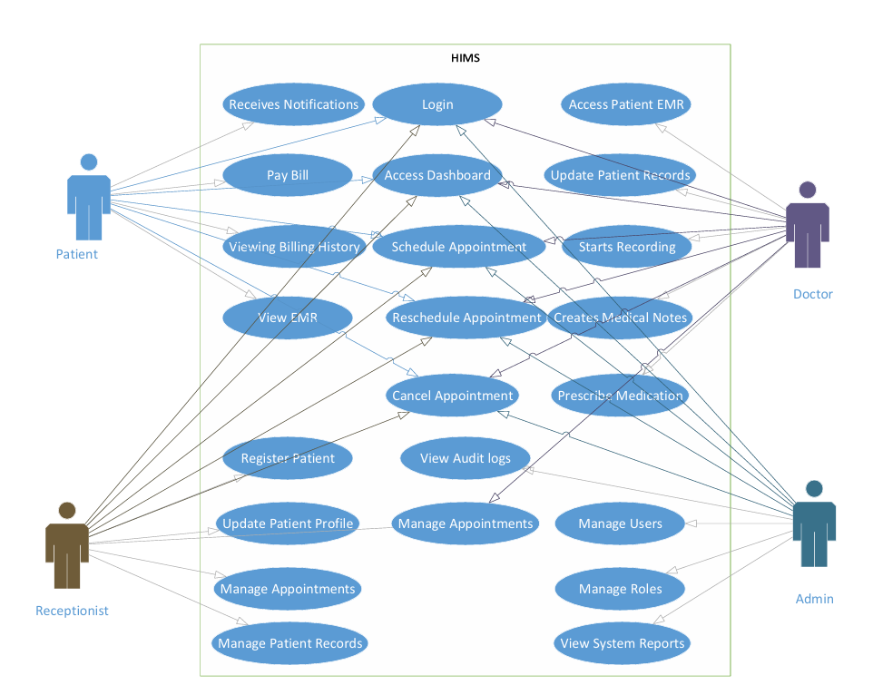
Figure 6.1 Use Case Diagram

Use Case 1: AI-Assisted Medical Documentation
Actors: Doctors
Use case ID: 21
Pre-condition:
The doctor must be authenticated into the system, and the voice recording service must be active.
Scenarios:
Step# | Action | Software Reaction
1 | Doctor starts consultation session. | The system activates voice recording and prepares the consultation workspace.
2 | Doctor and patient communicate during consultation. | The system captures and transcribes the conversation in real time.
3 | Doctor finishes consultation. | The AI extracts medical details such as symptoms, diagnosis, medications, and recommendations.
4 | Doctor reviews generated notes. | The system displays structured medical reports and SOAP notes for verification.
5 | Doctor confirms or edits the notes. | The verified consultation report is securely stored in the database.
Alternate Scenarios:
- If voice recognition fails or audio quality is poor, the doctor can manually edit or enter medical notes.
- If the AI generates incomplete information, the system allows manual correction before saving.
Post Conditions:
Step | Description
1 | Verified consultation records are stored securely in the database.
2 | Patient medical history is updated with the latest consultation data.

Use Case 2: Appointment and Queue Management
Actors: Patients, Receptionists
Use case ID: 22
Pre-condition:
Patient account must exist and the doctor schedule must be available in the system.
Scenarios
Step# | Action | Software Reaction
1 | Patient requests an appointment. | The system checks doctor availability and assigns an appointment slot.
2 | Receptionist confirms appointment details. | The system generates a queue position for the patient.
3 | Patient checks queue status. | The system displays real-time queue updates and estimated waiting information.
4 | Patient arrives at hospital. | The system updates queue progression and consultation status.
Alternate Scenarios:
- If appointment slots are full, the system suggests the next available schedule.
- If the patient misses the appointment, the system marks the session as missed or rescheduled.
Post Conditions:
Step | Description
1 | Appointment and queue data are stored in the system.
2 | Patients receive updated scheduling and queue information.

Use Case 3: Patient Record Access
Actors: Doctors, Patients, Receptionists
Use case ID: 23
Pre-condition:
Authorized users must be logged into the system.
Scenarios
Step# | Action | Software Reaction
1 | User searches for a patient record. | The system retrieves the patient’s medical history from the database.
2 | Doctor reviews previous consultations and prescriptions. | The system displays reports, prescriptions, and visit history.
3 | Patient requests downloadable reports. | The system generates downloadable PDF reports.
4 | Receptionist verifies patient details. | The system updates or confirms patient information if required.
Alternate Scenarios:
- If the requested record does not exist, the system displays an appropriate notification.
- If unauthorized access is attempted, the system blocks access and logs the activity.
Post Conditions
Step | Description
1 | Authorized users access accurate patient information securely.
2 | Medical records remain updated and centrally managed.

Use Case 4: Prescription Management
Actors: Doctors, Patients
Use case ID: 24
Pre-condition:
Patient consultation must be completed and verified by the doctor.
Scenarios
Step# | Action | Software Reaction
1 | Doctor creates or updates prescription. | The system stores prescription details in the database.
2 | Doctor reviews previous medication history. | The system displays earlier prescriptions and treatment records.
3 | Patient accesses prescription information. | The system provides digital prescription access and download options.
Alternate Scenarios:
- If prescription information is incomplete, the system prompts the doctor for corrections.
- If duplicate medications are detected, the system alerts the doctor for review.
Post Conditions
Step | Description
1 | Prescription records are securely maintained.
2 | Patients receive verified prescription information digitally.

Use Case 5: Secure Communication and Notifications
Actors: Doctors, Patients, Receptionists
Use case ID: 25
Pre-condition:
Users must be authenticated and connected to the system.
Scenarios
Step# | Action | Software Reaction
1 | User sends a healthcare-related message. | The system securely delivers the message to the intended recipient.
2 | System generates appointment or billing notification. | Notification is sent through dashboard alerts or email service.
3 | User opens communication history. | The system displays previous messages and notifications.
Alternate Scenarios:
- If message delivery fails, the system retries or notifies the sender.
- If invalid recipient information is entered, the system displays an error message.
Post Conditions
Step | Description
1 | Healthcare communication is securely maintained.
2 | Users receive important alerts and updates on time.

Chapter 07: Implementation Overview

7.1 Technology Stack

Languages & Frameworks
- Python
- JavaScript
- Django
- ReactJS
Frontend
- ReactJS Web Dashboard
- HTML5, CSS3, and Tailwind CSS for responsive user interface design
Backend
- Django (Python) for backend development and business logic
- Django REST Framework (DRF) for API development and communication
Database & Storage
- PostgreSQL for structured hospital and patient data storage
- Local/Cloud storage for reports, prescriptions, and uploaded documents
Artificial Intelligence & Voice Processing
- Speech Recognition / ASR Engine for voice-to-text conversion
- NLP-based processing for extracting medical information and generating structured notes
- AI-assisted medical report and SOAP note generation
Authentication & Security
- Django Authentication System
- Role-Based Access Control (RBAC) for Admins, Doctors, Receptionists, and Patients
- Cookie-based authentication mechanisms
APIs & Data Exchange
- REST APIs for frontend-backend communication
- JSON format for data transfer
- SMTP/Email APIs for notifications and appointment alerts
Reporting & Document Generation
- PDF generation libraries for downloadable reports and prescriptions
- CSV export support for hospital records and analytics
Deployment & Hosting
- Windows environment for development
- Linux Server for backend hosting and deployment
- Cloud or local server deployment support
Monitoring & Maintenance
- System activity logging
- Error monitoring and debugging tools
- Database backup and recovery support
Version Control & Collaboration
- Git
- GitHub for source code management and collaboration

7.2 System Architecture Overview
The AI Powered Hospital Information Management System (HIMS) follows a modular client-server architecture where the frontend, backend, database, and AI processing components communicate through REST APIs and secure database connections. The architecture is designed to support scalability, maintainability, and efficient healthcare workflow management.
- The ReactJS frontend provides dashboards and interfaces for doctors, administrators, receptionists, and patients. It communicates with the backend services through REST APIs to manage appointments, patient records, prescriptions, billing, and hospital operations.
- The Django backend handles business logic, authentication, role-based access control, API processing, and communication with the database. It also manages AI-assisted medical documentation and system operations.
- The AI and voice-processing modules capture doctor-patient conversations, process speech-to-text transcription, and generate structured medical reports and SOAP notes for doctor verification before storage.
- PostgreSQL is used as the central database system for storing patient records, appointment details, prescriptions, billing information, user accounts, and hospital activity logs.
- External services such as email APIs may be integrated for appointment notifications, billing alerts, password recovery, and communication support.
- The system supports secure communication between frontend and backend components using JSON-based REST APIs, ensuring efficient data exchange and system interoperability.
- The architecture is designed with modular components so that future integrations, upgrades, and additional AI functionalities can be added with minimal impact on existing system operations.
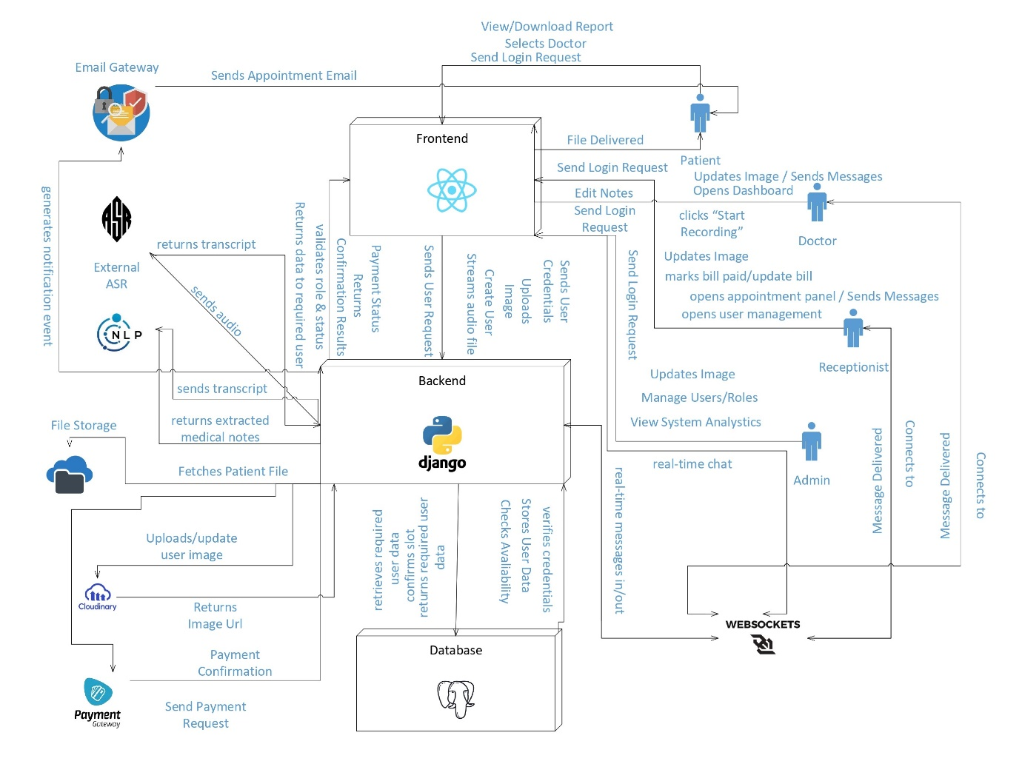
Figure 7.1 System Architecture Diagram
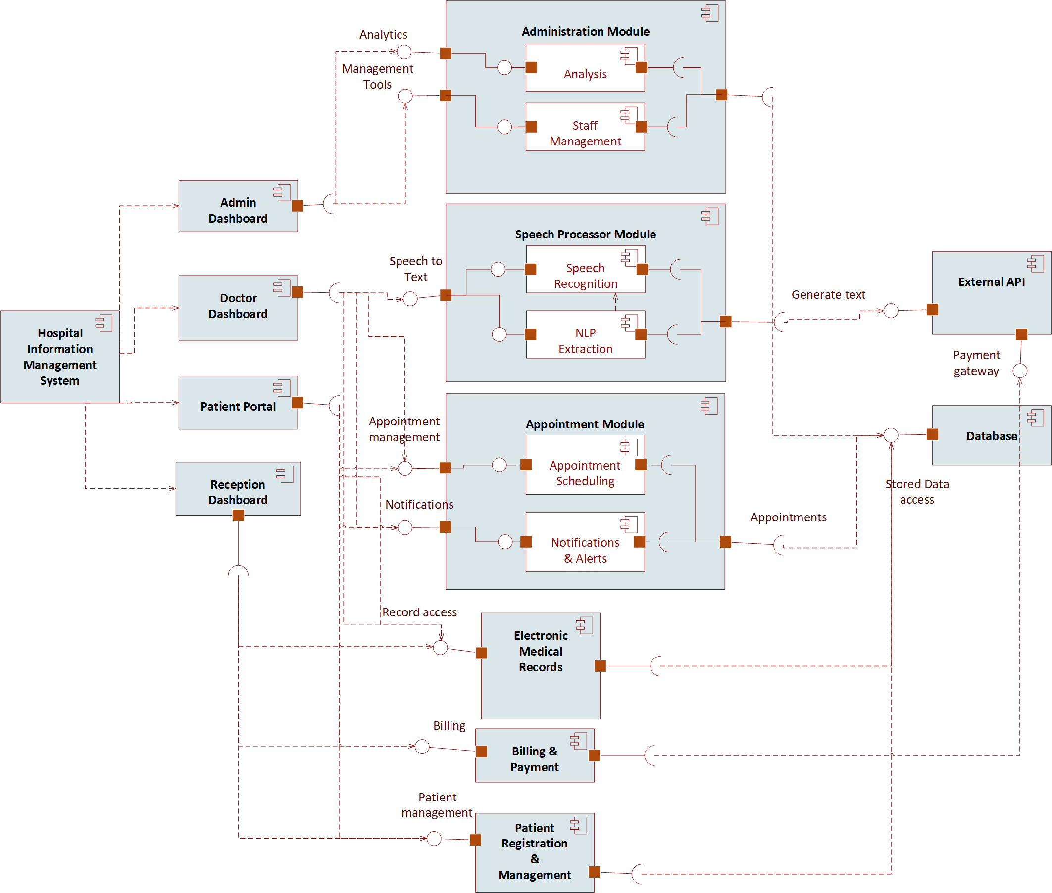
Figure 7.2 Component Diagram

7.3 Module Implementations

7.3.1 AI Consultation Recording & Documentation Module
Flow:
• Doctor-patient conversation is captured through microphone input →
• Speech-to-text processing converts conversation into text →
• NLP-based processing extracts important medical information such as symptoms, diagnoses, medications, and recommendations →
• Structured medical reports and SOAP notes are generated →
• Doctor reviews, edits if necessary, and confirms the generated notes →
• Verified records are stored in the PostgreSQL database.
Features:
• Voice-based consultation recording
• Automatic SOAP note & medical report generation
• Doctor validation before saving
• Secure storage of consultation history
• Support for English, Urdu, and Punjabi languages
UI Elements:
• Voice recording controls
• Consultation history panel
• AI-generated summary preview
• SOAP note editor and confirmation interface
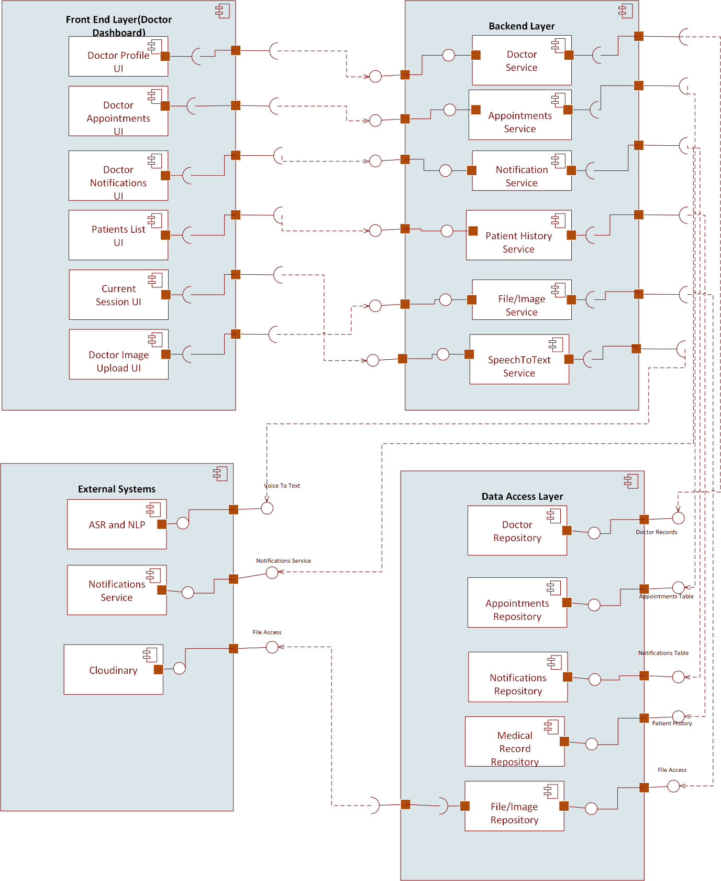
Figure 7.3.1 Doctor Component Diagram

7.3.2 Appointment & Queue Management Module
Flow:
• Patient requests appointment →
• Receptionist or patient schedules appointment →
• System assigns queue position on a first-come-first-serve basis →
• Real-time queue status is updated dynamically →
• Patient receives appointment and queue information through dashboard or notifications.
Features:
• Online appointment booking
• Real-time queue tracking
• Doctor-specific appointment management
• Queue status updates
• Appointment history management
UI Elements:
• Appointment booking form
• Queue status display
• Doctor schedule panel
• Receptionist management dashboard

7.3.3 Patient Record & Prescription Management Module
Flow:
• Doctor verifies consultation notes →
• Medical reports and prescriptions are stored in the database →
• Authorized users retrieve patient history when required →
• Patients can access reports and prescriptions through the patient portal.
Features:
• Centralized patient medical records
• Prescription history management
• Downloadable medical reports
• Doctor-specific treatment history
• Secure record access
UI Elements:
• Patient profile dashboard
• Prescription viewer
• Medical history tables
• Report download interface
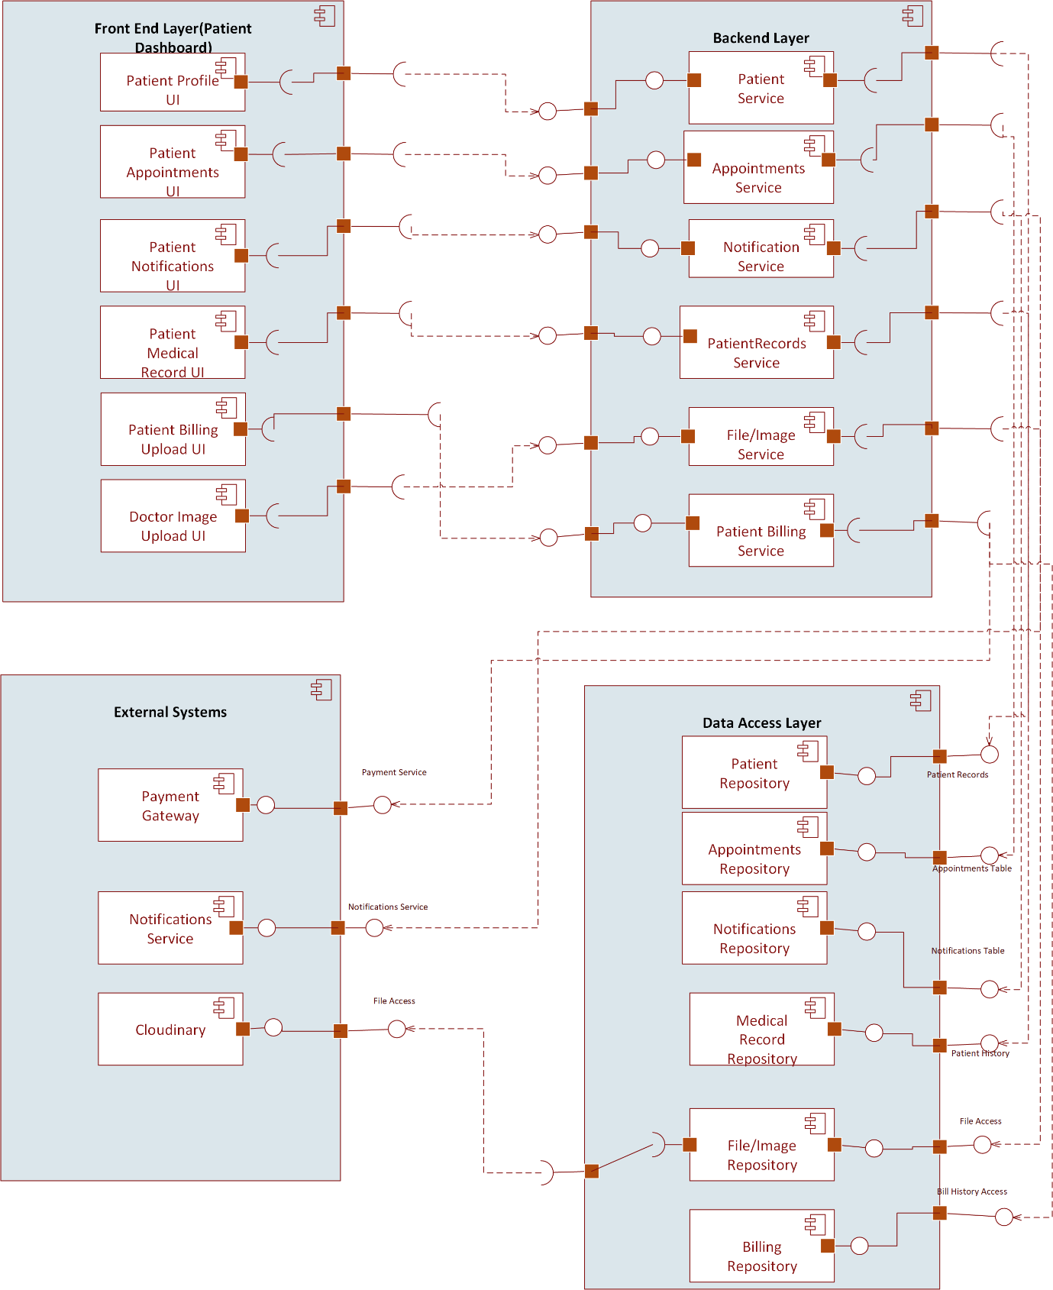
Figure 7.3.2 Patient Component Diagram

7.3.4 Communication & Notification Module
Flow:
• Messages or notifications are generated by the system or healthcare staff →
• Notifications are sent through dashboard alerts or email services →
• Users can view communication history and updates within the system.
Features:
• Secure healthcare-related messaging
• Appointment notifications and reminders
• Billing and report notifications
• Follow-up communication support
UI Elements:
• Messaging interface
• Notification panel
• Conversation history section

7.3.5 Administrative Dashboard Module
Features:
• User management and account approval
• Doctor and receptionist assignment management
• Hospital activity monitoring
• Patient and appointment analytics
• Billing and operational management
UI Elements:
• Analytics dashboard
• User management tables
• Activity monitoring panels
• Billing and reporting sections
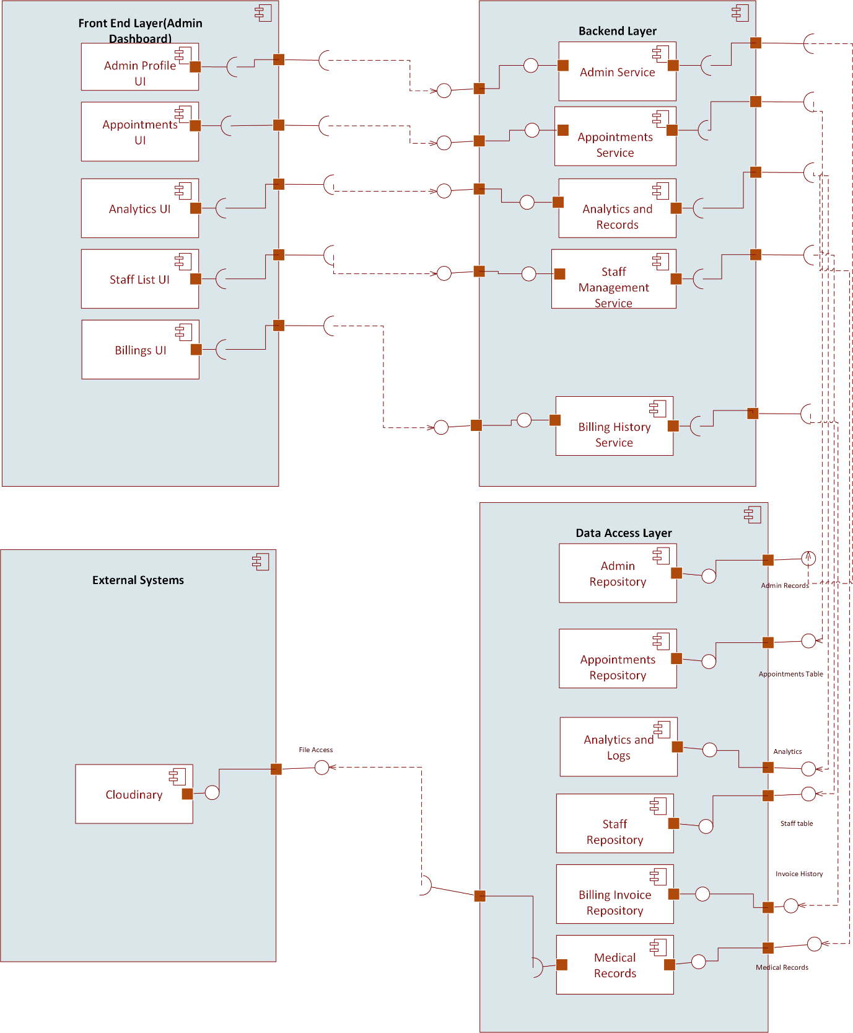
Figure 7.3.3 Admin Component Diagram

7.3.6 Authentication & Access Control Module
Features:
• Secure login and authentication
• Role-Based Access Control (RBAC)
• Controlled patient account approval
• Session management and access restrictions
Supported Roles:
• Administrator
• Doctor
• Receptionist
• Patient
UI Elements:
• Login and registration forms
• Account approval dashboard
• Password recovery interface
• Role management controls
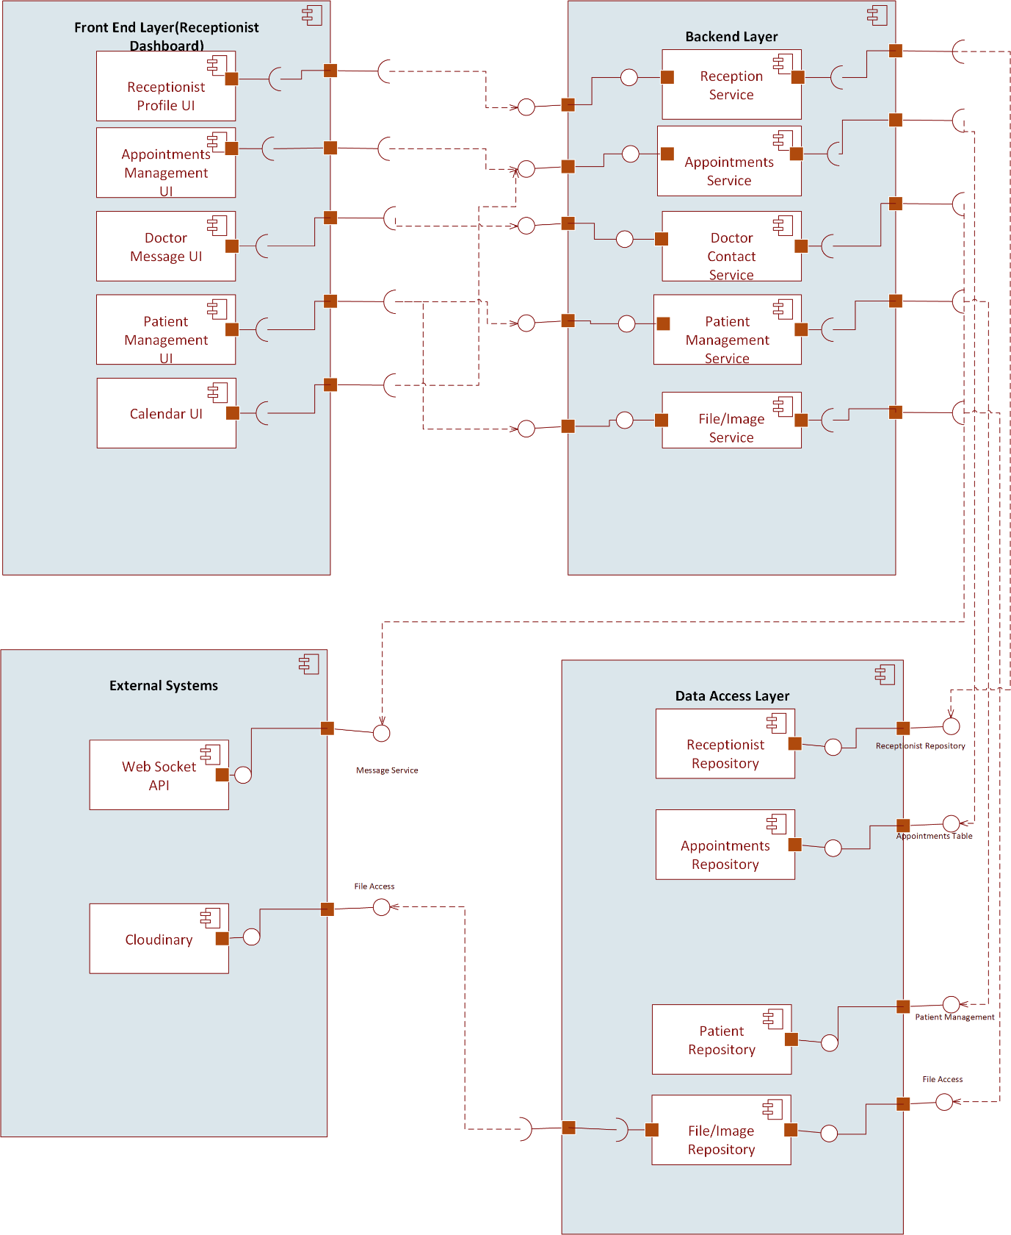
Figure 7.3.4 Receptionist Component Diagram

7.4 Deployment Strategy

7.4.1 Frontend Application
- Doctors, administrators, receptionists, and patients deploy the ReactJS frontend dashboard on a web hosting platform (Netlify).
- The frontend communicates securely with backend APIs for real-time hospital operations and data management.

7.4.2 Backend Service
- The Django backend service is deployed on a Linux-based server environment.
- Backend services manage authentication, hospital workflows, database communication, AI-assisted documentation, and REST API processing.
- Environment variables are used for secure configuration of database credentials, API keys, and system settings.

7.4.3 Database Deployment
- PostgreSQL is used as the central database system for storing patient records, appointments, prescriptions, billing information, and system logs.
- Regular backup mechanisms are maintained to ensure data recovery and reliability.

7.4.4 AI & Voice Processing Services
- Speech recognition and NLP processing modules are integrated with the backend system for voice-to-text conversion and structured medical report generation.
- AI processing components communicate securely with the backend through API-based integration.

7.4.5 File & Report Management
- Medical reports, prescriptions, and uploaded documents are stored using secure local or cloud-based storage systems.
- PDF generation services are integrated for downloadable reports and prescriptions.

7.5 Code/API Documentation
- Django REST Framework APIs are documented for frontend-backend communication and system integration.
- Internal project documentation and module descriptions are maintained through GitHub repositories and README files.
- API endpoints include proper request/response structures and authentication guidelines for developers and future maintenance.
- System architecture, database schema, and workflow documentation are maintained to support future upgrades and scalability.

Chapter 08: Design Document

8.1 State Transition Diagram
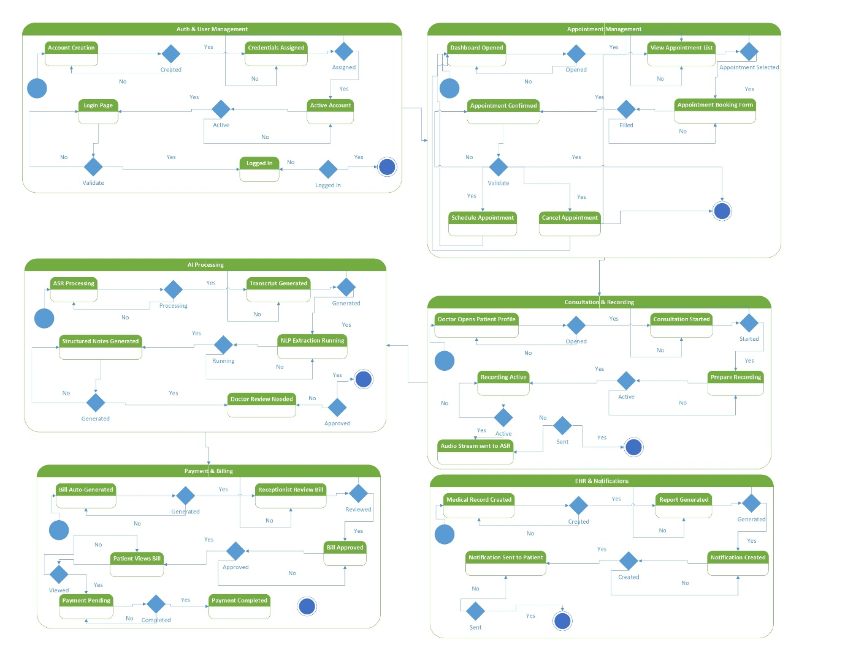
Figure 8.1 State Transition Diagram

8.2.1 DFD Level 0
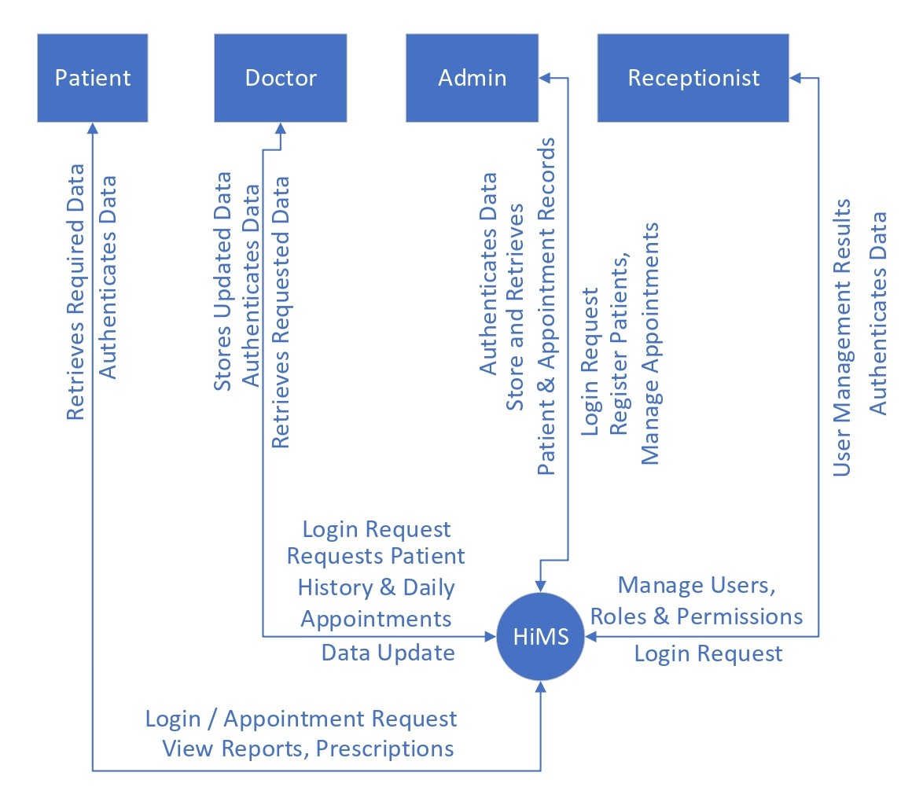
Figure 8.2.1 DFD Diagram (Level 0)

8.2.2 DFD Level 1
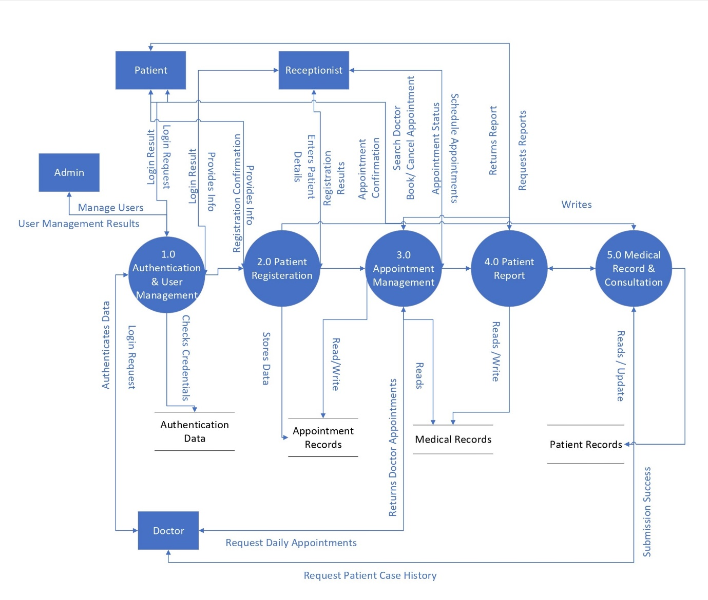
Figure 8.2.2 DFD Diagram (Level 1)

8.2.3 DFD Level 2
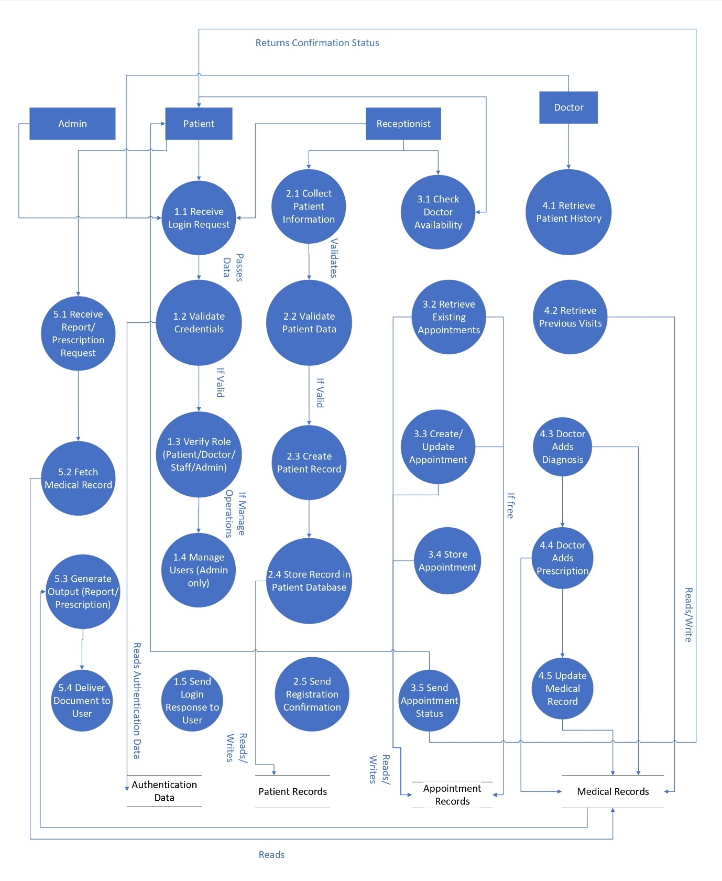
Figure 8.2.3 DFD Diagram (Level 2)

8.3 Class Diagram

8.4 Sequence Diagram
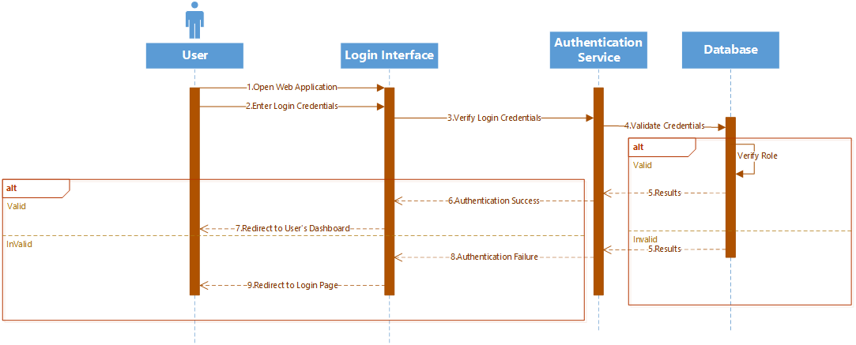
Figure 8.4.1 Sequence Diagram (Login)
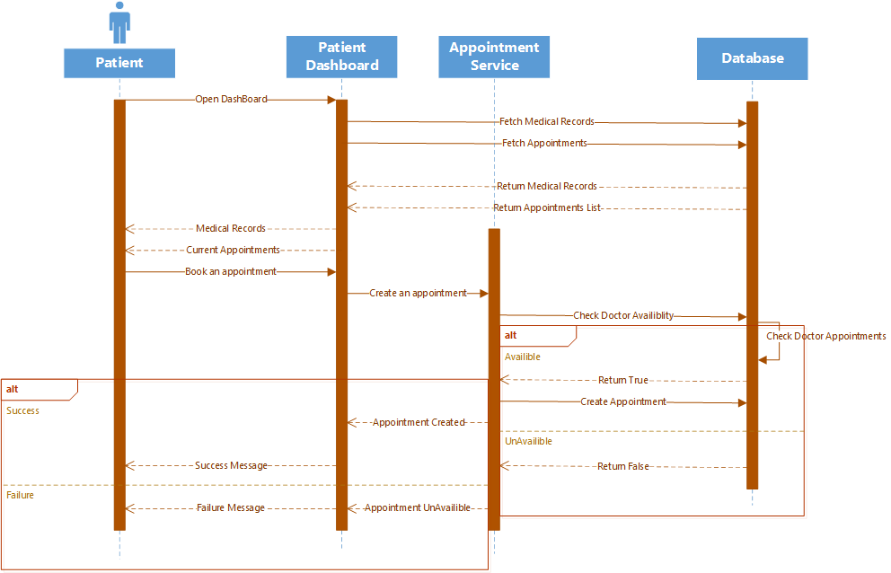
Figure 8.4.2 Sequence Diagram (Patient)
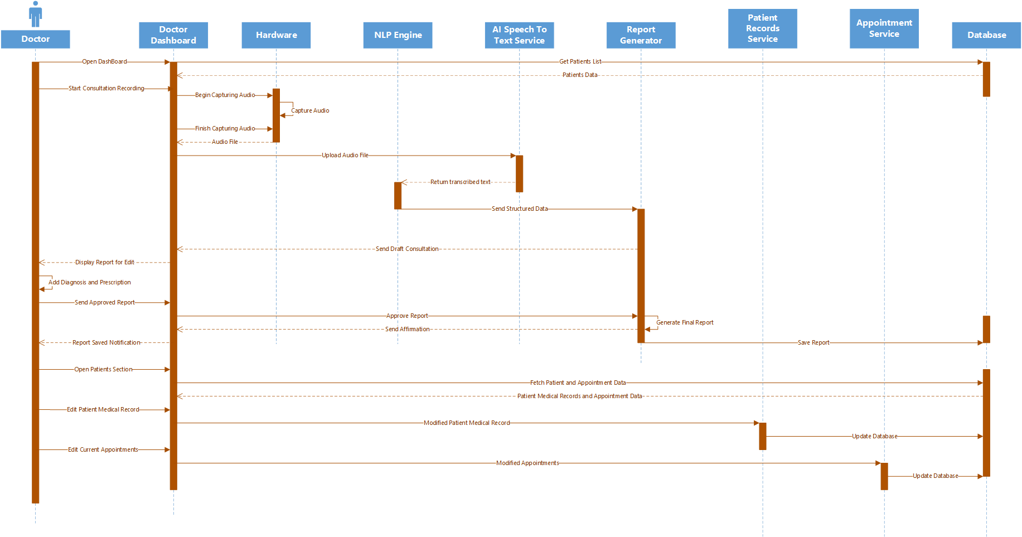
Figure 8.4.3 Sequence Diagram (Doctor)
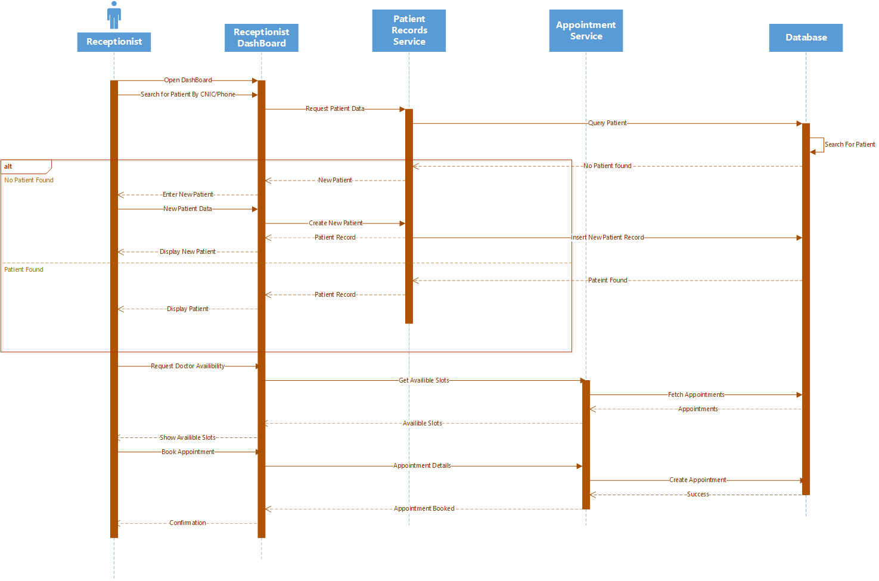
Figure 8.4.4 Sequence Diagram (Receptionist)
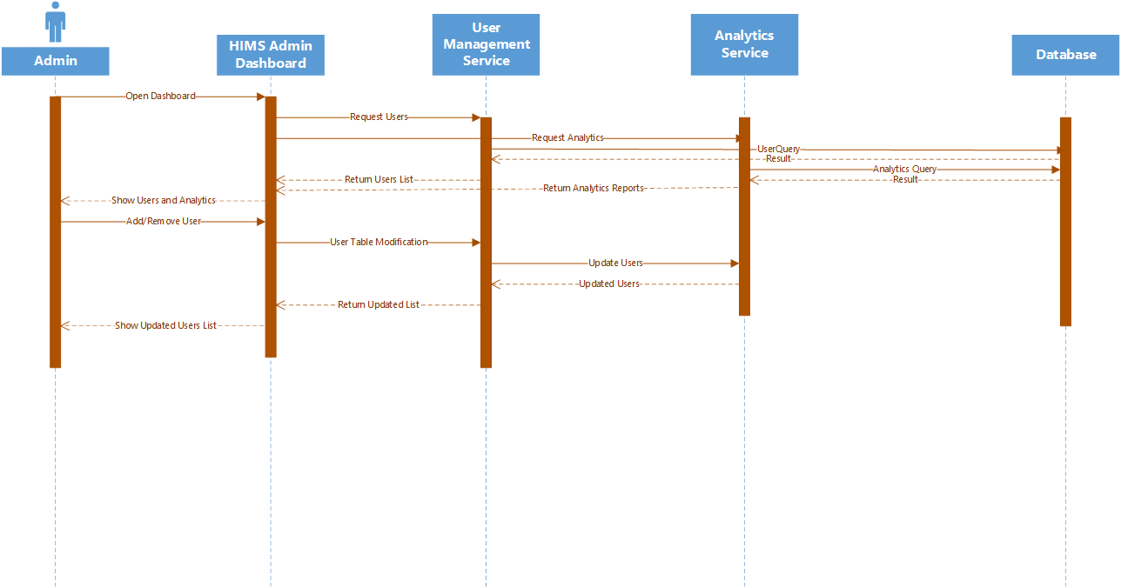
Figure 8.4.5 Sequence Diagram (Admin)

8.5 ER Diagram

Chapter 09: UI Interfaces

9.1 Landing Page
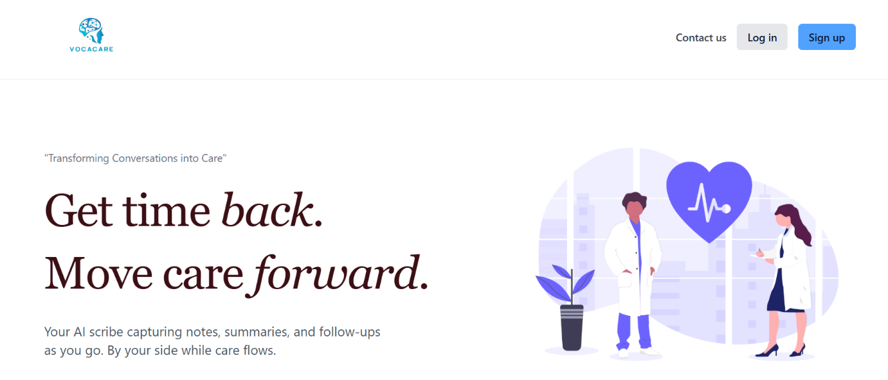
Purpose & Context:
- Entry point to the system for all user roles.
- Introduces the platform and leads users to login or signup.
Element Details:
1.Branding Area
- Vocacare logo
- Tagline: “Transforming conversations into care.”
2.Primary Actions
- Sign In Button → navigates to Sign in page.
- Log In Button → navigates to Login page.
User Flow (Landing Page)
1. User clicks “Sign In”
System Action:
Redirects to Register Page.
2. User clicks “Log In”
System Action:
Redirects to Login Page.
3. User returns to landing
System Action:
- No state stored; fresh page reload.

9.2 Register and Login Page

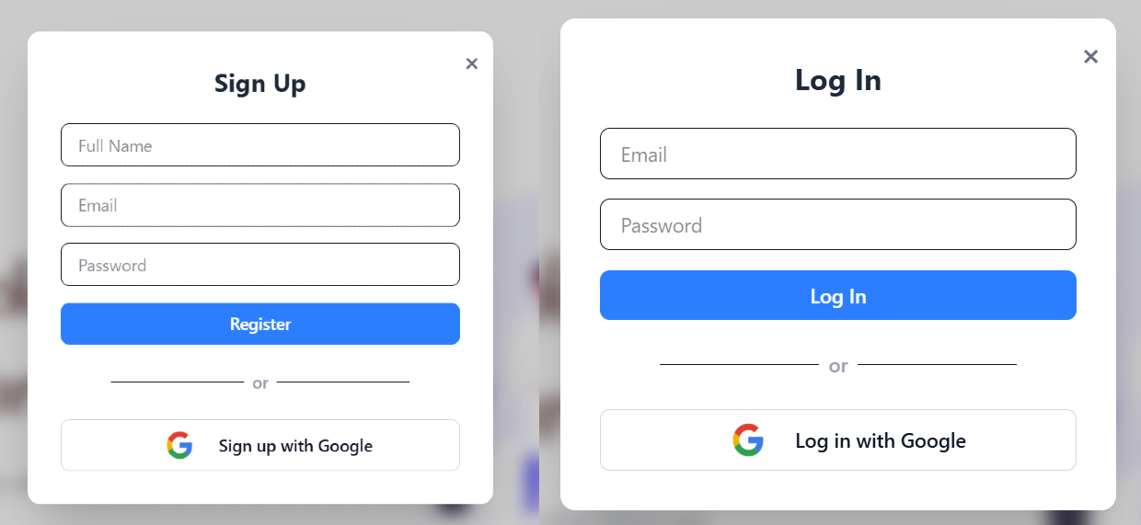
Purpose & Context
Secure access to the system for all roles.
Element Details
Login Form
- Email input
- Sign In button
- Error messages
- Log in with Google
Register Form
- Email input
- Name input
- Password input
  - Register Button
User Flow
1. Enter Email + Password → Click Sign In
System Actions:
- Validate email format
- Validate password length
- Send credentials to API
- If valid → redirect to relevant dashboard
- If invalid → show inline error: “Incorrect email or password.”
2. Enter Name+ Email + Password → Click Register
System Actions:
- Validate email format
- Validate password length
- Send credentials to API
- If valid → redirect to relevant dashboard
- If invalid → show inline error: “Invalid email or password.”

9.3 Dashboard

9.3.1 Patient Dashboard
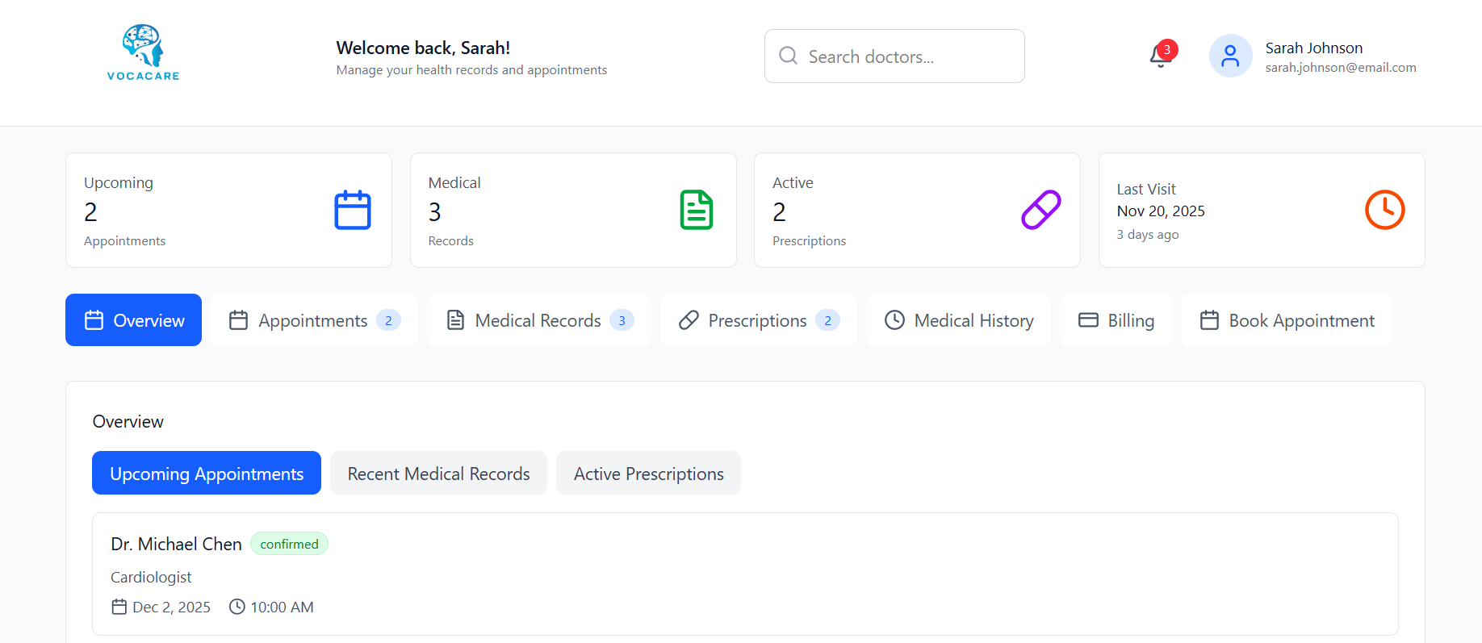
Purpose & Context
Allow patients to manage bookings, medical records, prescriptions, invoices.
Element Details
Header
- Logo
- Welcome
- Search
- Notifications
- User profile
Modules
- Upcoming Appointments
- Medical History
- Prescriptions
- Billing Summary
- Quick Actions
User Flow
1. Patient books an appointment
System Action:
- Opens calendar
- Select doctor, date, time
- Confirm
- Appointment appears in dashboard
2. Patient views medical history
System Action:
- Load personal medical timeline
- Click entry → opens details
3. Patient pays invoice
System Action:
- Redirect to billing
- Choose payment method
- Confirm payments
4. Patient clicks notification bell
System Action:
- Dropdown opens
- Notifications marked as read when viewed
5. Patient edits profile
System Action:
- Update profile
- Save and refresh

9.3.2 Doctor Dashboard
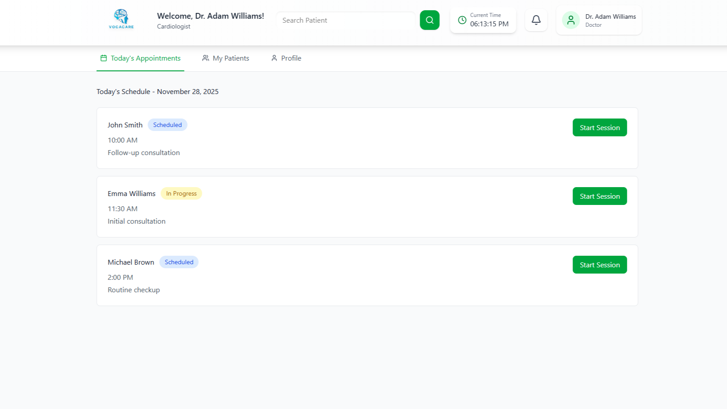
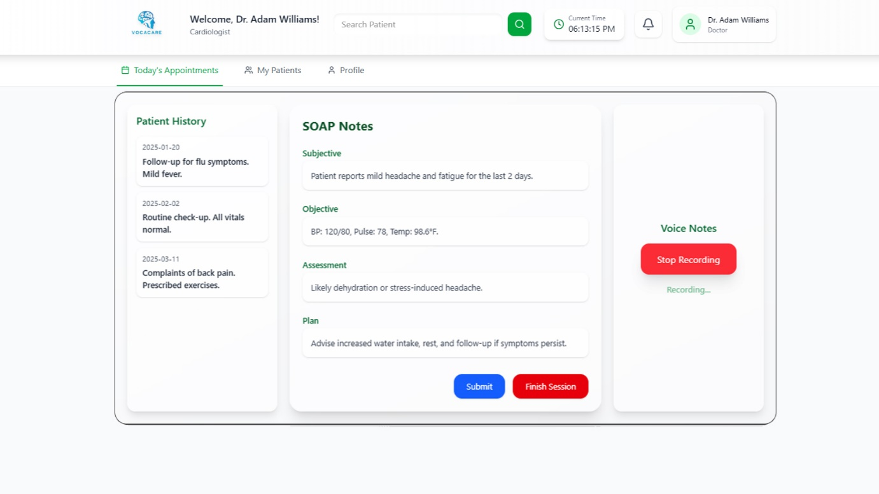
Purpose & Context
Daily workflow for doctors: appointments, patients, medical history, SOAP sessions.
Element Details
Header
- Logo + welcome
- Search patients
- Current time
- Notifications
- User menu
Tabs
- Today’s Appointments
- My Patients
- Profile
Session Modal
- Left: Patient history
- Center: SOAP notes
- Right: Voice recorder
- Submit + Finish Session
User Flow
1. Doctor clicks “Start Session”
System Action:
- Opens fullscreen
- Loads patient history + SOAP template
- Initializes microphone permissions (if allowed)
2. Doctor edits SOAP Notes
System Action:
- Auto-save draft locally
- Highlight unsaved changes
3. Doctor clicks “Start Recording”
System Action:
- Ask for mic permission
- Begin audio capture
- Display “Recording…” pulse state
4. Doctor clicks “Stop Recording”
System Action:
- Save audio blob
- Display playback option (optional)
5. Doctor clicks “Submit”
System Action:
- Validate SOAP fields
- Upload notes + audio
- Close modal + mark appointment as “Completed”
- Toast: “Session Submitted.”
6. Doctor clicks “Finish Session”
System Action:
- Close modal
- Return to appointments tab
7. Doctor searches for a patient
System Action:
- Trigger global search
- Clicking a patient opens detailed profile
8. Editing profile
System Action:
- Save doctor info
- Refresh UI

9.3.3 Receptionist Dashboard
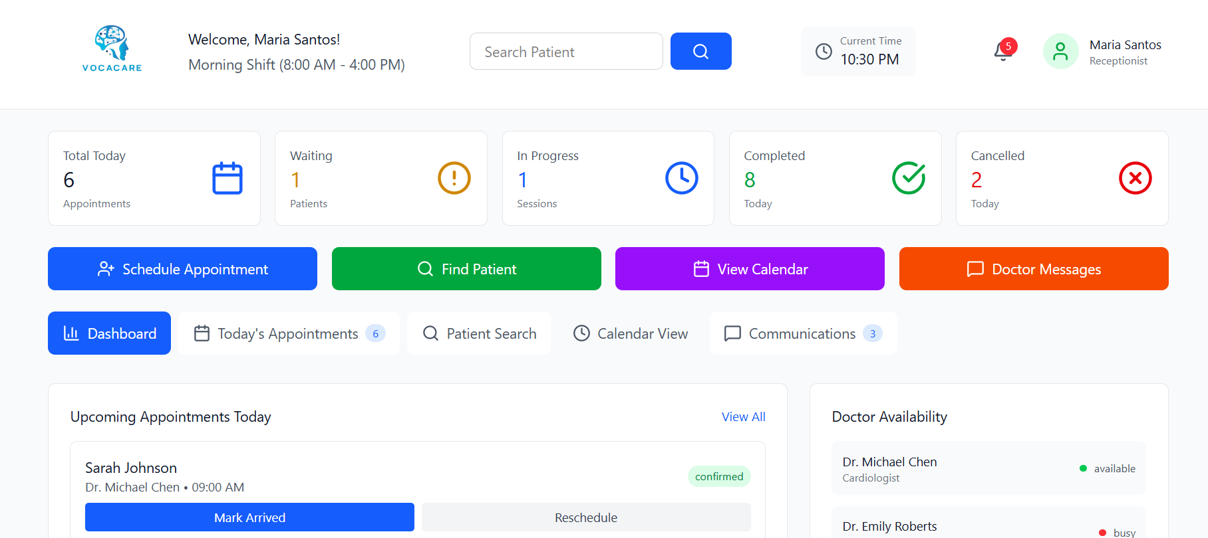
Purpose & Context
Manage patients, check-ins, appointments, scheduling, reception workflow.
Element Details
Header
- Logo
- Welcome section
- Search patients
- Current time display
- Notifications dropdown
- User menu (profile, settings, logout)
Main Modules
- Today’s appointments
- Patient search
- Quick actions (Register patient, Book appointment)
- Appointment overview tables
User Flow
1. Receptionist searches for a patient
System Action:
- Query patients
- Show list of matches
- Click result → open patient profile
2. Receptionist clicks “Check-In”
System Action:
- Mark appointment as “Arrived”
- Update doctor’s appointment list
- Toast: “Patient checked in.”
3. Click “Book Appointment”
System Action:
- Redirect to appointment form
- Pre-fill patient info if patient was selected
4. Clicking Notifications Icon
System Action:
- Dropdown opens
- Mark notifications as read when viewed
5. Clicking User Profile
System Action:
- Show menu options
- Selecting logout → return to login

9.3.4 Admin Dashboard
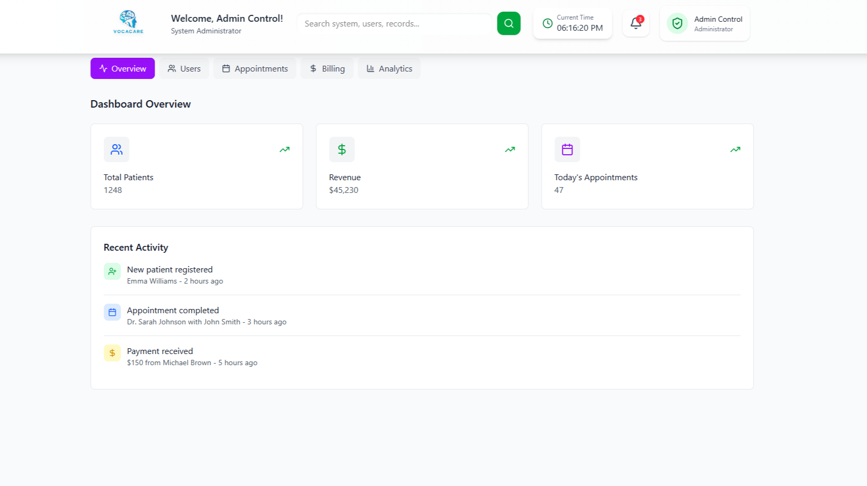
Purpose & Context
Complete management of system users, analytics, departments, billing, logs.
Element Details
Header
- Welcome admin
- Global search (search users, departments, roles)
- Current time
- Notifications
- Admin menu
Main Sections
- Overview
- Users
- Appointments
- Billing
- Analytics
User Flow
1. Admin uses global search
System Action:
- Search across:
  - users
  - doctors
  - receptionists
  - departments
  - logs
- Click result → navigate to detail page
2. Admin adds a user
System Action:
- Open create-user modal
- Fill details
- Save → User list refreshes
3. Admin views analytics
System Action:
- Load charts (appointments, revenue, user activity)
- Switch timeframe filters
4. Admin edits system roles
System Action:
- Open role editor
- Assign permissions
- Save updates
5. Notifications dropdown
System Action:
- Mark events as read
6. Logout
System Action:
- Clear session
- Redirect to login

Chapter 10: Functionality & Performance Testing

Chapter 11: References

- AI Scribe & Clinical Assist. (n.d.). Retrieved from CureMD:
https://www.curemd.com/ai-medical-scribe

- Brian D Tran, Yunan Chen, Songzi Liu, Kai Zheng. (2020, May 01). How does medical scribes’ work inform development of speech-based clinical documentation technologies? Retrieved from JAMIA:
https://academic.oup.com/jamia/article-abstract/27/5/808/5809107

- Cameron G. Shultz and Heather L. Holmstrom. (2015, May 28). The Use of Medical Scribes in Health Care Settings: A Systematic Review and Future Directions. Retrieved from JAFBFM:
https://www.jabfm.org/content/28/3/371.short

- Castillo, Sachin Shah, Deborah L. Burnet & Wei Wei Lee. (2021, July 11). Impact of a medical scribe on clinical efficiency and quality in an academic general internal medicine practice. Retrieved from Springer Nature Link: https://link.springer.com/article/10.1186/s12913-021-06710-y

- Enrico Coiera, Baki Kocaballi, John Halamka & Liliana Laranjo . (2018, October 16). The digital scribe. Retrieved from npj digital medicine: https://www.nature.com/articles/s41746-018-0066-9

- Get time back . Move care forward. (2025). Retrieved from Heidi: https://www.heidihealth.com/
- Gregory Finley, Erik Edwards, Amanda Robinson, Michael Brenndoerfer, Najmeh Sadoughi, James Fone, Nico Axtmann, Mark Miller, David Suendermann-Oeft. (2018, June 01). An automated medical scribe for documenting clinical encounters. Retrieved from ACL Anthology: https://aclanthology.org/N18-5003/

- jfgonsalves. (n.d.). phlox. Retrieved from Github:
https://github.com/bloodworks-io/phlox

- Save 2 hours a day with an AI medical scribe. (2025). Retrieved from NoteMD: https://www.notemd.ai/

- Sully AI. (2025). Retrieved from Superhuman team of AI-employees for healthcare: https://www.sully.ai/

- The digital scribe. (2018, October 16). Retrieved from npj digital medicine : . (n.d.). Retrieved from
https://www.nature.com/articles/s41746-018-0066-9

